Lesson 5:
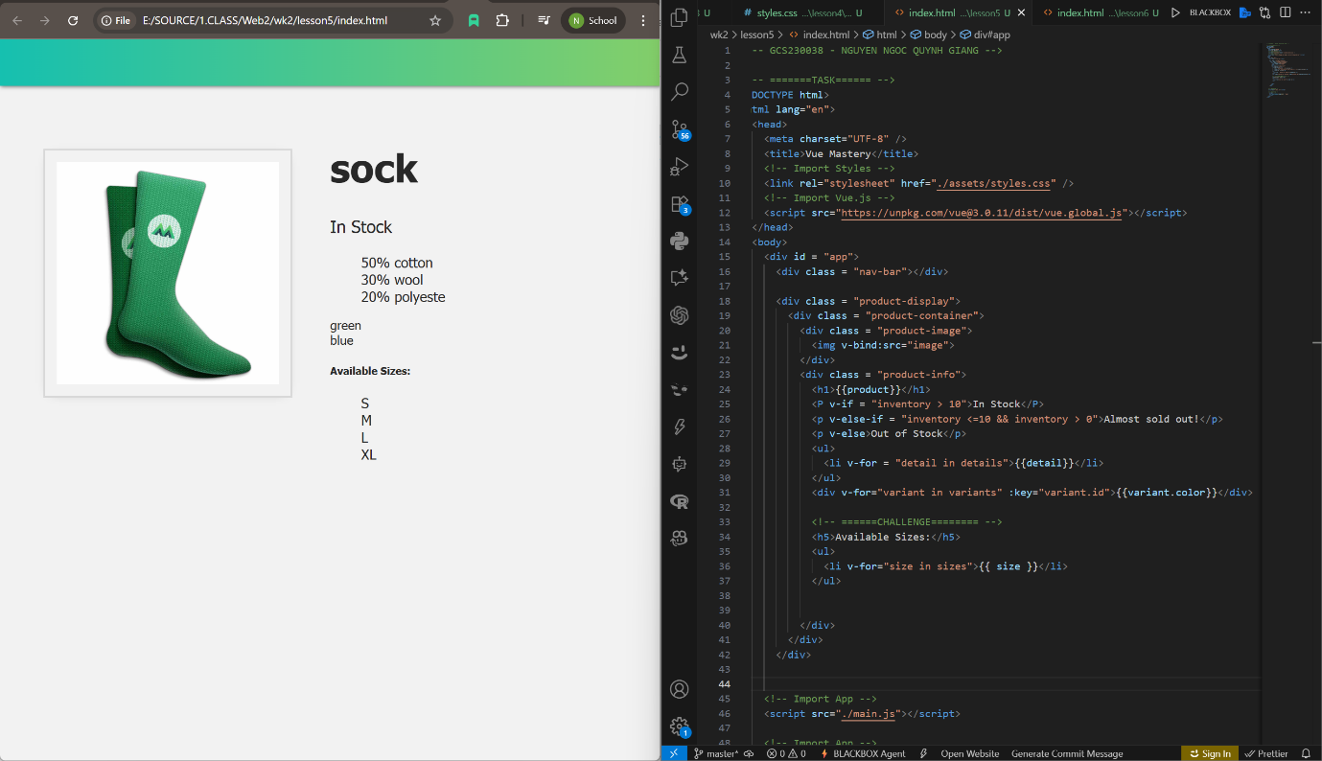
Figure 1. Task & Challenge for lesson 5
Lesson 6:
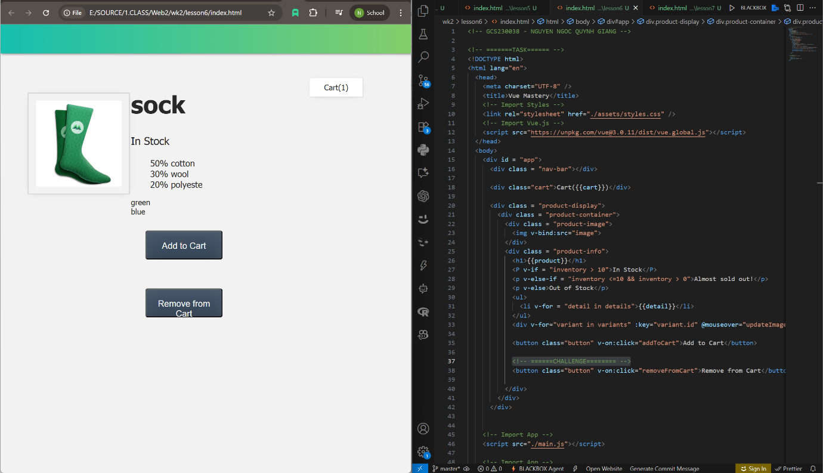
Figure 2. Task & Challenge for lesson 6
Lesson 7:
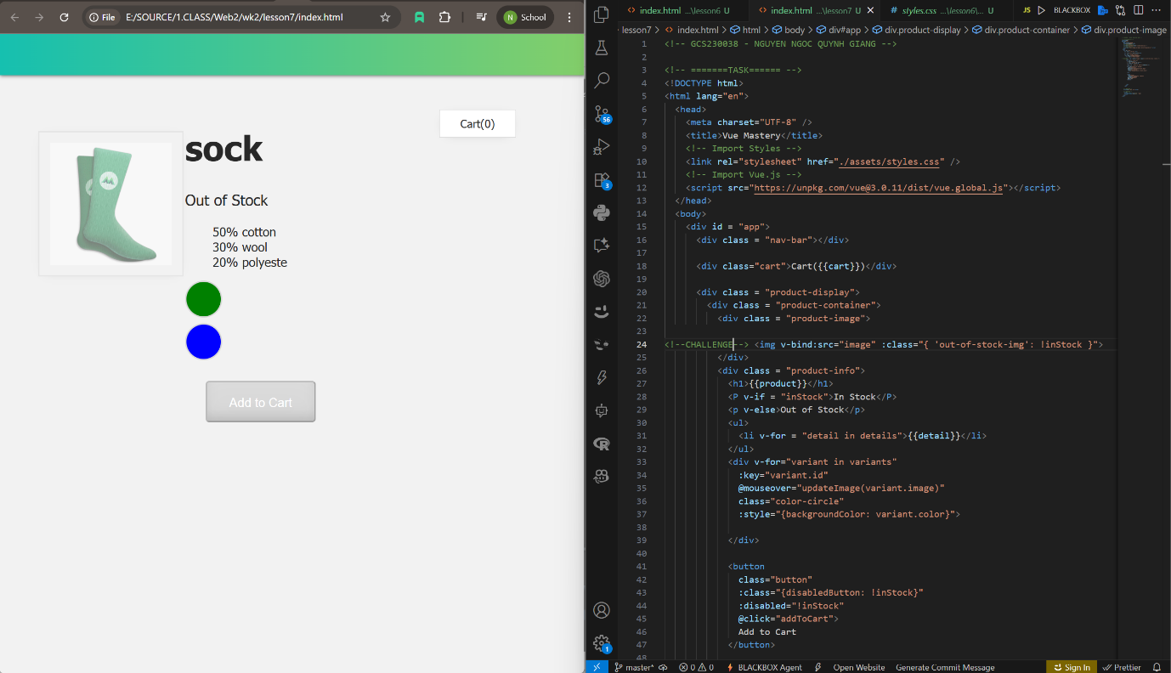
Figure 3. Task & Challenge for lesson 7
Understanding:
In lesson 5, I learned how to display an HTML list from an array of data in the js file. By using v-for, the loop goes through all the values in the array and prints out a list in HTML. It is also possible to assign an id and element for an array; by adding :key with the id in v-for, the loop will print the color element corresponding to that id. This can be practically applied on e-commerce platforms to help sellers quickly update product status, descriptions, and information.
In lesson 6, I learned how to use v-on to create click events and increase the quantity of items in the cart each time the click button is pressed. There are two ways to do this: a simple method that just adds the statement cart += 1 after v-on:click, and a more advanced method requiring a function setup in the js file. Additionally, using the mouseover event, the displayed image can be changed through v-for and an array pre-defined in the js file. The add to cart feature can be applied on all sales websites, as well as other types like movie or story websites (where instead of adding to cart, it can be used to add movies, stories, or music to a playlist).
In lesson 7, there is no need to assign a specific color value directly in the v-for loop; instead, the array defined in js is used. This makes editing element values easier. Also, the disabled attribute can make a button appear disabled when inStock = false. This feature helps clearly show the product’s status and prevents users from adding sold-out items to the cart for purchase.

